|  |  |  |  |
| --- | --- | --- | --- |
| \\lyng-dc1\StaffShared\Learning Bugs Animals ALL subjects\characters bugs animals\Cyril the Snail - History.jpeg**Lyng Primary School Knowledge Organiser** | | | |
| **History Topic:** | **What is the impact of how the Egyptians communicated?** | Year 5  *Civilisation and Communication* | Autumn 2 |

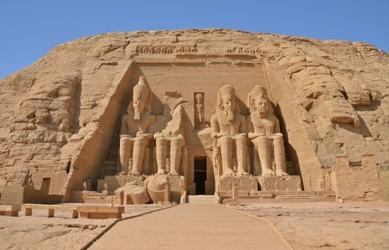

**Background information for parents and teachers.** Egypt is located in the northeast corner of Africa. The Ancient Egyptians lived along the banks of the River Nile in Egypt. It was farmers who first settled there around 5000 BC. Two separate kingdoms (ruled by different kings) developed along the Nile River. The kingdom in Upper Egypt was called the red crown. In about 3200 BC the pharaoh of the north conquered the south and Egypt became united. The pharaoh’s name was King Memphis. In the Greek language, the word Memphis meant “Balance of the Two Lands.” Egypt was one of the greatest civilisations of the past. The monuments and tombs of their pharaohs continue to stand intact today, 4000 year later.

|  |  |
| --- | --- |
| **What Step On and Goldilocks words will I use?** | |
| **Spelling** | **Definition** |
| Hieroglyphics | A type of writing that used a combination of pictures and symbols |
| Canopic jar | Special jars that held the organs of mummified people including lungs, intestines and liver. |
| Cartouche | A carved tablet or drawing representing a scroll bearing an inscription |
| Viscera | Collective noun for the internal organs removed in mummification |
| Rosetta Stone | Used to decipher the hieroglyphics. |
| Natron | Salt used to dry out the bodies during mummification process |
| Hierarchy | Social structure |
| Dynasty | Line of hereditary rulers |
| Vizier | A high official |
| Embalming | Preparing the body for the afterlife |
| Akhenaten | The name of a pharaoh who disbanded all other Gods. |



|  |  |
| --- | --- |
| **When? (Timeline of key events)** | |
| 3100BC - 30BC | Ancient Egyptian era |
| 2950BC | Memphis is built |
| 2640 BC | First pyramid is believed to have been built |
| 2575 – 2150 BC | The Great Pyramids are built |
| 2125 – 1975 BC | Egypt is divided |
| 1975 – 1640 BC | Egypt is reunited |
| 1332 BC | The 10 year rule of Tutankhamun begins |
| 305 BC | The start of the Ptolemaic Era |
| 196BC | The Rosetta Stone is carved |
| 51 BC | Queen Cleopatra’s reign begins. She is the last Pharaoh of the ancient Egypt period |
|  |  |

**Hook  
Artefact Hunt  
Mummification – taking the organs out.**

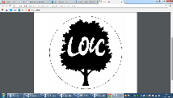

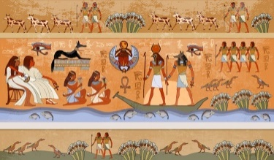



**TRIP/VISITOR**

**Trip to Severn Valley Country Park to compare to River Nile.**

“What I hate is ignorance, smallness of imagination, the eye that sees no further than its own lashes. All things are possible… who you is limited only by who you think you are.” – Egyptian Book of the Dead.

**Great Quotes**

**Our Storytelling Approach to enhance engagement**

|  |  |  |
| --- | --- | --- |
| **People:**  Pharaohs  Nobles, priests, viziers, embalmers. | **Place:**  Egypt | **Problem:**  You need to mummify a pharaoh. |

**Key Facts and Famous Figures**

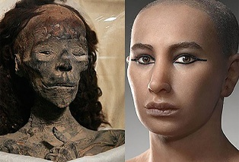

Pharaoh Tutankhamun - Tutankhamun was an Egyptian pharaoh of the 18th dynasty, during the period of Egyptian history known as the New Kingdom. **Tutankhamun** was born a prince in Egypt's royal court around the year 1341 BC. His father was the Pharaoh Akhenaten. **Tutankhamun's** birth name was Tutankhamen, which he changed after his father died. **Tutankhamun** was born to one of his father's lesser wives and not to his main wife, the powerful Nefertiti.

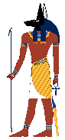

**Anubis** is the Protector of the gates to the underworld, Osiris replaced him as the god of the dead. He looks like a man with the head of a jackal. The black jackal head of this jackal-god was characterized by its long, alert ears and a pointed muzzle. The color black was highly significant as it was a **symbol** of death, the color of rotting flesh, and symbolized the Underworld and the night.

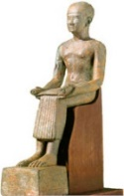

A commoner, **Imhotep** rose through the ranks at court to become so respected as a sage, architect, and healer that he was later deified and worshipped as a god. Today he is best known for building the Step Pyramid, one of the world's earliest stone monuments and the first pyramid in Egypt.

**Key skills – Taken from Milestone 3 – Sequence of Learning**

Q: How can we use artefacts to learn about life in Ancient Egypt?  
Q: What key historical events occurred in Ancient Egypt?  
Q: How was Ancient Egyptian society structured?  
Q: Is the Rosetta Stone the most important discovery of the Ancient Egyptian era?

|  |
| --- |
| \\lyng-dc1\StaffShared\Learning Bugs Animals ALL subjects\characters bugs animals\Cyril the Snail - History.jpeg**Lyng Primary School Knowledge Organiser** |

|  |  |  |
| --- | --- | --- |
| **People:**  Pharaohs  Nobles, priests, viziers, embalmers. | **Place:**  Egypt | Image result for egyptian quiz**Problem:**  You need to mummify a pharaoh. |

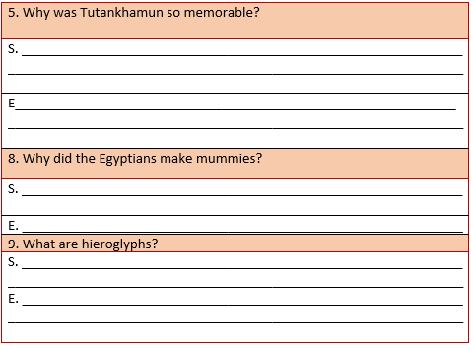

|  |  |  |
| --- | --- | --- |
| 1. What can be found inside an Egyptian mummy? | **S** | **E** |
| Bandages |  |  |
| Internal organs |  |  |
| Sawdust and linen |  |  |
| 2. True or false – The Egyptians tried to stop the River Nile flooding. Explain. | **S** | **E** |
| True |  |  |
| False |  |  |
| 3. What is the name given to the canal system used to obtain water from annual floods? | **S** | **E** |
| Irrigation |  |  |
| Interrogation |  |  |
| 4. How many years ago did the Ancient Egyptian era begin? | **S** | **E** |
| 3100 BCE |  |  |
| 30 BCE |  |  |
| 300 BCE |  |  |